Touchstone Award and Garden Research Studies

Legacy receives highest honor for garden design; new study shows nature reduces burnout in nurses
The Oregonian
https://www.oregonlive.com/portland/index.ssf/2013/06/legacy_emanuel_medical_center_8.html

Healthcare Design Magazine
https://www.healthcaredesignmagazine.com/projects/landscaping-exteriors/legacy-emanuel-medical-center-plants-purpose/

Legacy Terrace Garden Dedication: April 14, 2014
http://www.youtube.com/watch?v=DyQnTX1zkMM

Lippincott Nursing Center
https://www.nursingcenter.com/journalarticle?Article_ID=4110425&Journal_ID=54008&Issue_ID=4109816 The impact of a hospital garden on pregnant women and their partners

Medical Construction & Design
https://mcdmag.epubxp.com/i/909550-nov-dec-2017/19
Journal article explores relationship between therapeutic gardens, birthing experience

Health Facilities Management

https://www.hfmmagazine.com/articles/3161-health-system-studies-therapy-gardens-affect-on-icu-nurses

American Journal of Critical Care
http://ajcc.aacnjournals.org/content/27/6/508
The impact of nurses taking daily work breaks in a hospital garden on burnout

Legacy Story Center
https://www.legacyhealth.org/our-legacy/stay-connected/story-center/stories/2018-stories/people/2018-11-nurses-study.aspx

Becker’s Hospital Review
https://www.beckershospitalreview.com/quality/why-hospitals-should-let-nurses-take-outdoor-breaks.html

The Advisory Board
https://www.advisory.com/daily-briefing/2018/11/15/garden-walks?WT.mc_id=Email|DailyBriefing+Headline|DBA|DB|2018Nov15|ATestD

2018 Healthcare Design conference award film Phoenix, Arizona
Legacy Emanuel’s research garden second floor Terrace Garden: https://youtu.be/gEaLQ_7gQH0.
2018 is the second year The Center for Health Design has awarded the Evidence-Based Design Touchstone Award. This award is given to recognize outstanding projects throughout the world that demonstrate exemplary achievement across the touchstones of the EBD process; collaboration, evaluation, and sharing.
Why research matters top 10 HCD.pdf

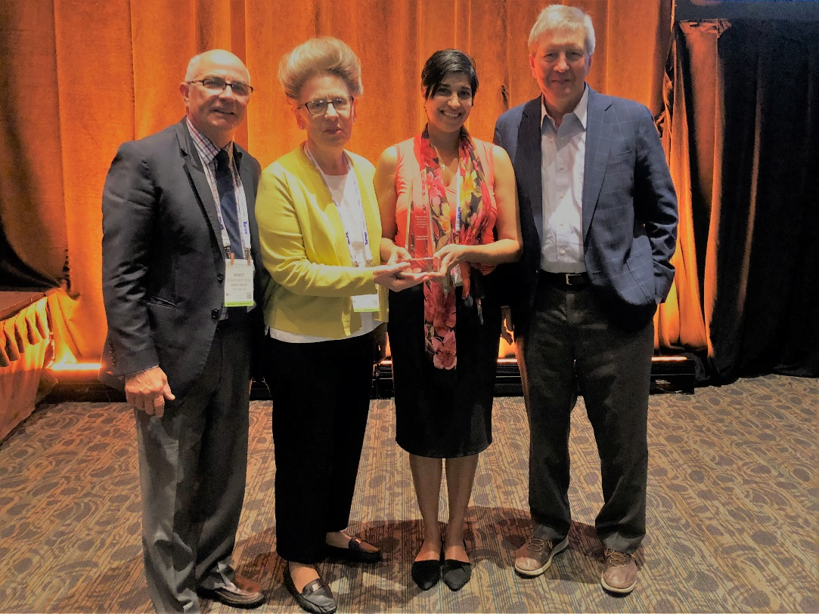

Accepting the 2018 Evidence-Based Design Touchstone Award Platinum level
https://www.healthdesign.org/certification-outreach/awards-recognition/evidence-based-design-touchstone-awards-presented-center
Minot Cleveland, M.D. Medical Director for Employee Health, Legacy Health
Teresia Hazen, MEd, HTR, QMHP Coordinator for Legacy Therapeutic Garden Program
Serene Perkins, M.D., FACS, Director of Surgical and Clinical Research for Legacy Research Institute
Roger S. Ulrich, Ph.D., EDAC, FASLA, co-project investigator, Chalmers University, Sweden

The Lund Report
https://www.thelundreport.org/content/press-release-legacys-therapeutic-garden-receives-highest-honor

Nature Sacred: A Nature Place Heart of the Hospital launches:
https://naturesacred.org/heart-of-the-hospital-launches/

The Scribe the official publication of the Medical Society of Metropolitan Portland “A healing garden: A nature place at Legacy Emanuel offers relaxation to providers”
https://indd.adobe.com/view/dc65b326-bb08-493d-91d0-6df683076950

January 2019 “Impact of a garden on ICU patient families” submitted to a peer reviewed journal.

Teresia Hazen, MED, HTR, QMHP
Coordinator, Legacy Therapeutic Garden Program
www.legacyhealth.org/gardens
thazen@lhs.org
1.19.19

